**NAME: PARTH NITESHKUMAR PATEL**

**ID: 19DCS098**

**CLASS: CSE 2**

**SUBJECT: JAVA**

**WEEK-5**

**1. Write a java program which takes two integers x & y as input, you have to compute x/y. If x and y are not integers or if y is zero, exception will occur and you have to report it.**

**CODE:**

import java.util.*;

class SP_23

{

public static void main (String args[])

{

float result;

Scanner input = new Scanner(System.in);

System.out.print("Enter Num-1: ");

int n1 = input.nextInt();

System.out.print("Enter Num-2: ");

int n2 = input.nextInt();

try

{

result = n1/n2;

System.out.println("Answer :"+result);

}

catch (NumberFormatException e)

{

System.out.println("Format of the Number is wrong!");

}

catch (ArithmeticException e)

{

System.out.println("Number cannot be divided by zero");

}

}

}

}

**OUTPUT:**

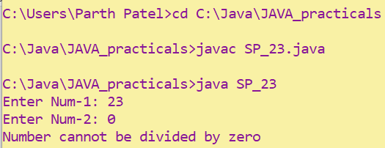

**2. A piece of Java code is given below. You have to complete the code by writing down the handlers for exceptions thrown by the code. The exceptions the code may throw along with the handler message are listed below:**

**Division by zero: Print "Invalid division". String parsed to a numeric variable: Print "Format mismatch". Accessing an invalid index in string: Print "Index is invalid". Accessing an invalid index in array:**

**Print "Array index is invalid".**

**MyException: This is a user defined Exception which you need to create. It takes a parameter param. When an exception of this class is encountered, the handler should print "MyException[param]", here param is the parameter passed to the exception class.**

**Exceptions other than mentioned above: Any other exception except the above ones fall in this category. Print "Exception encountered". Finally, after the exception is handled, print "Exception Handling Completed".**

**Example: For an exception of MyException class if the parameter value is 5, the message will look like MyException[5].**

**CODE:**

import java.util.*;

class MyException extends Exception

{

int n1;

public MyException(int n)

{

this.n1 = n;

} void printout()

{

System.out.println("MyException["+n1+"]");

}

}

class SP_24

{

public static void main (String args[])

{

try

{ Scanner sc = new Scanner(System.in);

int n1 = 2/2;

System.out.print("Enter String:");

String str = sc.next();

int n2 = Integer.parseInt(str);

int n3[] = {1,2};

n3[1] = 5;

String s = "PNP";

s.charAt(5);

throw new MyException(5);

}

catch(NumberFormatException e)

{

System.out.println("Number format is wrong!");

}

catch(ArithmeticException e)

{

System.out.println("Division by zero is not defined!");

}

catch(ArrayIndexOutOfBoundsException e)

{

System.out.println("The Array index you have entered is invalid!");

}

catch(StringIndexOutOfBoundsException e)

{

System.out.println("The String index you have entered is invalid");

}

catch(MyException ex)

{

ex.out();

} finally

{

System.out.println("Exception Handling Completed");

}

}

}

**OUTPUT:**

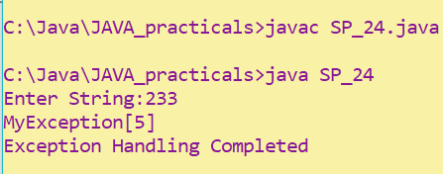

**3. Write a java program to generate user defined exception using “throw” and “throws” keyword. Also write a java with a differentiate checked and unchecked exceptions. (Mention at least two checked and two unchecked exception in program). CODE:**

import java.util.*;

class Check {

void checkLicenseAge(int age)

{

if(age < 18)

System.out.println("Ineligible to get driving license");

else

System.out.println("Eligible to get driving license");

}

int division(int a,int b) throws ArithmeticException

{

return a/b;

}

}

class SP_25

{

public static void main(String []args)

{

Scanner input = new Scanner(System.in);

try{

Check c1 = new Check();

System.out.print("Enter age : ");

c1.checkLicenseAge(input.nextInt());

System.out.println(c1.division(222,0));

}

catch(InputMismatchException e)

{

System.out.println("number is not valid");

}

catch(ArithmeticException e)

{

System.out.println("division by zero is invalid");

}

}

}

**OUTPUT:**

